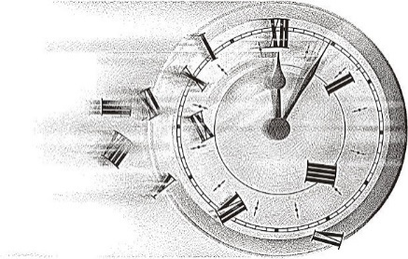

Back in time!

**Where are they going?**

**Vocab: Adjectives, Similes, Alliteration, Onomatopoeia, Personification**

**How will they get there?**

**Who is going back in time?**

Freya and Chester have gone back in time to the Age of the Vikings! They did it on a Norse Longship by way of magic runes, but there are many ways to go back in time, and many times you can visit!

Back in Time