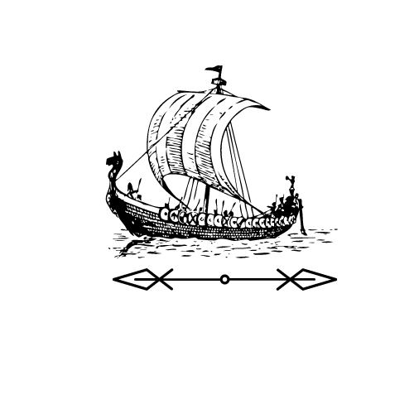
Extract from Enthralled: A Viking Saga
by Chris Wright, Chapter 20.

From the point of view of Chester

I knew it as soon as I saw them. Erik was the one guarding the boat, his hand on
his seax as he stood on the dock.
“We got you here, boy,” he said, “but you’re going to have to find your own
way back. The money we got for our goods isn’t enough to cover what we had
to go through to get here. This boat will cover the gap.”
Just for a second, my hand twitched towards my own seax. Rollo was armed
too, I knew, but all it took was a threatening step forward from the men on the
boat to convince me that it was useless. We were hopelessly outmuscled.
My last hope was Torsten, and I scanned the deck for him. I found him at last,
but though he wasn’t glaring at me like the others, and his hand wasn’t on his
axe, he wouldn’t meet my eye. He just pretended to be busy with the ropes, a
sad but determined look in his eyes.
A sudden surge of anger passed through me, and before I knew what I was
doing, I was striding onto the boat. A hand tried to grab me back, but I shrugged
it off and I marched straight up to Torsten. He jumped back at the sight of me.
His hand darted towards the hilt of his sword – the one he had taken from the
shield-maiden. But he didn’t draw it. Not yet.

Questions

1. A seax is a long viking knife. Why do you think Erik has his
hand on his at the start of the extract?

________________________________________________________________

________________________________________________________________

2. ‘The money we got for our goods isn’t enough to cover what we had to go through to get here. This boat will cover the gap.’ What does Erik mean by this?

They’re stealing the boat to make up for their trouble.
The boat will cover the gap between the sea and the dock.
They’ve sold the boat because they couldn’t sell their goods.
Chester stole the boat and they’re stealing it back.

3. What did Chester want to do when his hand ‘twitched towards his own seax’?

________________________________________________________________

4. What does ‘outmuscled’ mean here?

Knocked out The Vikings are too strong for them

Wrestled to the ground The Vikings have the ship

5. Who did Chester think was his final hope?

________________________________________________________________

6. Why won’t Torsten meet Chester’s eyes?

He’s angry at Chester.
He doesn’t notice Chester
The sea water is in his eyes.
He is ashamed of betraying Chester.

7. Where did Torsten get his seax?

________________________________________________________________

8. Why did the author write ‘not yet’ after saying Torsten didn’t draw his seax?

________________________________________________________________

________________________________________________________________

Extract from Enthralled: A Viking Saga
by Chris Wright, Chapter 20.

From the point of view of Chester

I knew it as soon as I saw them. Erik was the one guarding the boat, his hand on
his seax as he stood on the dock.
“We got you here, boy,” he said, “but you’re going to have to find your own
way back. The money we got for our goods isn’t enough to cover what we had
to go through to get here. This boat will cover the gap.”
Just for a second, my hand twitched towards my own seax. Rollo was armed
too, I knew, but all it took was a threatening step forward from the men on the
boat to convince me that it was useless. We were hopelessly outmuscled.
My last hope was Torsten, and I scanned the deck for him. I found him at last,
but though he wasn’t glaring at me like the others, and his hand wasn’t on his
axe, he wouldn’t meet my eye. He just pretended to be busy with the ropes, a
sad but determined look in his eyes.
A sudden surge of anger passed through me, and before I knew what I was
doing, I was striding onto the boat. A hand tried to grab me back, but I shrugged
it off and I marched straight up to Torsten. He jumped back at the sight of me.
His hand darted towards the hilt of his sword – the one he had taken from the
shield-maiden. But he didn’t draw it. Not yet.

Questions

1. What do you think Chester knew ‘as soon as I saw them’?

________________________________________________________________

________________________________________________________________

2. A seax is a long viking knife. Why do you think Erik has his
hand on his at the start of the extract?

________________________________________________________________

________________________________________________________________

3. ‘The money we got for our goods isn’t enough to cover what we had to go through to get here. This boat will cover the gap.’ What does Erik mean by this?

They’re stealing the boat to make up for their trouble.
The boat will cover the gap between the sea and the dock.
They’ve sold the boat because they couldn’t sell their goods.
Chester stole the boat and they’re stealing it back.

4. Why does Chester’s hand ‘twitch towards his own seax’?

________________________________________________________________

________________________________________________________________

5. Why do the men on the boat take a threatening step forward?

________________________________________________________________

________________________________________________________________

6. What does ‘outmuscled’ mean here?

________________________________________________________________

________________________________________________________________

7. Why won’t Torsten meet Chester’s eyes?

He’s angry at Chester.
He doesn’t notice Chester
The sea water is in his eyes.
He is ashamed of betraying Chester.

8. What does Torsten do at the sight of Chester? Why do you think he does this?

________________________________________________________________

________________________________________________________________

________________________________________________________________

9. Where did Torsten get his seax?

________________________________________________________________

10. Why did the author write ‘not yet’ after saying Torsten didn’t draw his seax?

________________________________________________________________

________________________________________________________________

Answers
Lower Question Set

1. A seax is a long viking knife. Why do you think Erik has his
hand on his at the start of the extract?
To threaten Chester, as a warning, to protect himself or in case Chester attacks.

2. ‘The money we got for our goods isn’t enough to cover what we had to go through to get here. This boat will cover the gap.’ What does Erik mean by this?
They’re stealing the boat to make up for their trouble.

3. What did Chester want to do when his hand ‘twitched towards his own seax’?
Attack Erik or steal back the ship.

4. What does ‘outmuscled’ mean here?
The Vikings are too strong for them

5. Who did Chester think was his final hope?
Torsten

6. Why won’t Torsten meet Chester’s eyes?
He is ashamed of betraying Chester.

7. Where did Torsten get his seax?
From a shield-maiden.

8. Why did the author write ‘not yet’ after saying Torsten didn’t draw his seax?
To suggest he might draw it in the future.
Answers
Higher Question Set

1. What do you think Chester knew ‘as soon as I saw them’?
That he had been betrayed or that they had stolen the ship.

2. A seax is a long viking knife. Why do you think Erik has his
hand on his at the start of the extract?
To threaten Chester, as a warning, to protect himself or in case Chester attacks.

3. ‘The money we got for our goods isn’t enough to cover what we had to go through to get here. This boat will cover the gap.’ What does Erik mean by this?
They’re stealing the boat to make up for their trouble.

4. Why does Chester’s hand ‘twitch towards his own seax’?
Attack Erik or steal back the ship.

5. Why do the men on the boat take a threatening step forward?
To warn Chester against attacking.

6. What does ‘outmuscled’ mean here?
The Vikings are too strong for them

7. Why won’t Torsten meet Chester’s eyes?
He is ashamed of betraying Chester.

8. What does Torsten do at the sight of Chester? Why do you think he does this?
Jumps. He is startled/shocked/scared. He wasn’t expecting Chester to approach him.

9. Where did Torsten get his seax?
From a shield-maiden.

10. Why did the author write ‘not yet’ after saying Torsten didn’t draw his seax?
To suggest he might draw it in the future.

